Product Requirements Document

# Metadata & Dates

## Change Log

|  |  |  |
| --- | --- | --- |
| Name | Date | Changes |
|  |  |  |
|  |  |  |

## Team

|  |  |  |
| --- | --- | --- |
| Member | Role | EMail |
|  |  |  |
|  |  |  |

## Milestones

|  |  |
| --- | --- |
| Design Freeze | Date |
| End of Prototyping Phase | Date |
| End Engineering Validation Testing |  |
| End Design Validation Testing Phase |  |
| End Production Validation Testing Phase |  |
| Mass Production Start |  |
| Global Availability |  |
| Product Launch |  |

# Overview

## Introduction

Apple’s first-generation AirPods were among the first truly wireless in-ear headphones and generated phenomenal demand with sales units exceeding 16 million in just the first year after launch. Customer satisfaction surveys have reported a great need among users to personalize their product and improve the in-ear fit and audio quality. Users also express a desire for more compact earbuds with shorter microphone extensions. Observational studies show an opportunity to expand upon and improve touch interactions and the need for enhanced sound quality. These will be backed by technological developments such as the H1 wireless connectivity chip, Cypress CY8C4146FN PSoC, dual beam-forming microphones, Bluetooth 5.2, iOS 14, force-sensitive resistors, gyroscopes, and IR proximity sensors.

## Product Image

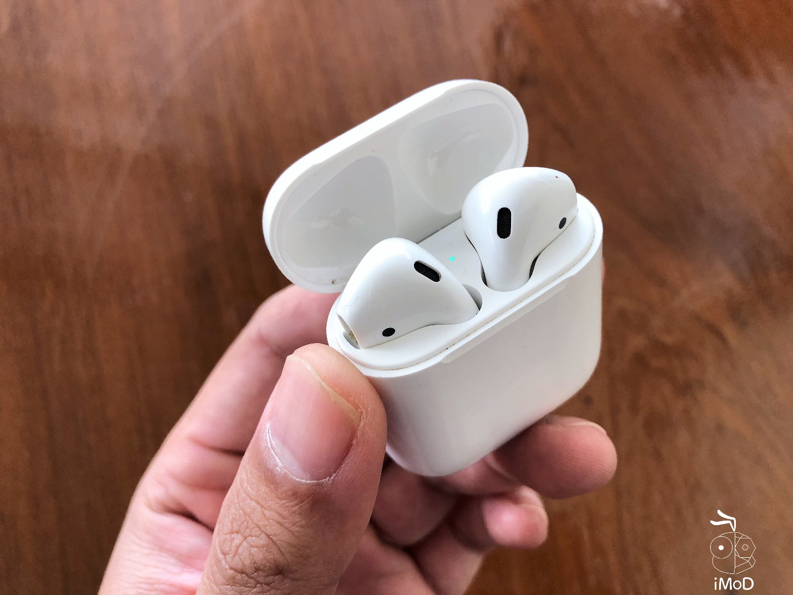

## Product Description

|  |  |
| --- | --- |
| Market Need | Why does the world need your product? |
| Key Features/ Functionality | What does your product do? |
| Other Product Compatibility,  Ecosystem, etc. | With which other systems does your product need to work? |

## Stakeholders

|  |  |
| --- | --- |
| Target User | Who will use your product? |
| Target Purchaser  (if different from user) | Who will buy your product? |
| Other Stakeholders | Who else should be considered? |

# Commercial and Regulatory

## Sale Info

|  |  |
| --- | --- |
| Countries of Sale | In which countries will you sell this version of the product? |
| Target Launch Date | When would you like it to be available? |

## Financials

|  |  |
| --- | --- |
| BOM Cost | How much do the components cost to make? |
| COGs | BOM Cost + assembly labor, freight forwarding, logistics, customs, duties, etc. |
| MSRP | Target retail price? |
| Acceptable Margin | How much do you need to earn when selling a unit? |

## Volume

|  |  |
| --- | --- |
| MOQ of First Production Run | How many do you need to make the first time you run your production line? |
| Annual Volume | How many do you expect to sell per year? |
| Timeline for Product Refresh (EOL) | How long before you launch your product’s replacement? |

## Regulatory Requirements

|  |  |
| --- | --- |
| Safety (UL, CE) | Which safety certifications are required? |
| Emissions (FCC, CE) | Which electrical radiation certifications are required? |
| Interoperability (Cellular, WiFi) | With which networks should your product operate? |

## Labeling

|  |  |
| --- | --- |
| Regulatory Marks | Which are required? |
| Country of Origin | Where was it assembled? |
| Serial Number | Does your product need a serial number? |

# Environmental

## Storage Environment

|  |  |
| --- | --- |
| Temperature Range | Through which temperature range might the product be stored? |
| Humidity Range | Through which humidity range might the product be stored? |

## Operating Environment

|  |  |
| --- | --- |
| Indoor, Outdoor, Wearable | Where and how will the product be used? |
| Temperature Range | Through which temperature range might the product be used? |
| Humidity Range | Through which humidity range might the product be stored? |

# Industrial design

## Renderings

## Identity

|  |  |
| --- | --- |
| Brand | What should your product communicate about your company values? |
| Color, Material, and Finish (CMF) | Which colors and textures will be used? |
| Logo size and placement | Where will the logo be placed? |

## Interfaces

|  |  |
| --- | --- |
| Connectors  (Power, USB, Lighting, Audio) | Which connectors, if any, does your product need? |
| Visual Interface  (Screen size and type, LEDs) | What will the product display, visually? |
| Touch Interface  (Mechanical actuators/switches, touch sensitivity, haptics) | How will people interact with their sense of touch? |
| Audio Interface  (Microphones, speakers) | Which audio inputs and outputs? |

# Software Architecture And Data Processing

## Block Diagram of Data Flow

# Electrical Hardware And Sensors

## Block Diagram of Electrical Hardware

## Electrical Requirements

|  |  |
| --- | --- |
| Input/Sensor Requirements | What should be sensed and to what accuracy? |
| Output/Actuator Requirements | How does the product affect its physical world? |
| Communication Requirements | With what and how fast does the product need to communicate? |
| Power Requirements | Should it be plugged into an outlet or powered with disposable or rechargeable batteries? If batteries, how long should it last between replacement or recharging? |

## Critical BOM Items

|  |  |  |  |
| --- | --- | --- | --- |
| Item Name | Internal S/N | Link to Source | Link to Datasheet |
|  |  |  |  |
|  |  |  |  |
|  |  |  |  |
|  |  |  |  |
|  |  |  |  |
|  |  |  |  |
|  |  |  |  |
|  |  |  |  |

# Mechanical Hardware & Materials

## Materials

|  |  |  |  |  |
| --- | --- | --- | --- | --- |
| Material | Type: | Used In: | Supplier | Link to MSDS |
|  |  |  |  |  |
|  |  |  |  |  |
|  |  |  |  |  |
|  |  |  |  |  |
|  |  |  |  |  |
|  |  |  |  |  |
|  |  |  |  |  |
|  |  |  |  |  |

## Circularity & Recyclability

# Durability

|  |  |
| --- | --- |
| Lifetime requirements | How long should the product last before it is unusable? |
| Cycles of various sub-systems | How long should specific parts of the product last? |
| Chemical resistance (sweat, sebum, sunscreen, salt water) | Which chemicals should the product resist? |
| UV resistance (sunlight) | Should be product be UV resistant? |
| Environmental (Dust, Water, etc.) | Dust or water? Use IPX codes here. |
| Mechanical (Drop, Vibration, Abrasion, etc.) | What mechanical abuse should the product withstand? |

# Packaging

|  |  |
| --- | --- |
| In the Box | What comes in the box? |
| Unboxing Experience | What should the user experience when unboxing the product? |
| Printing, colors, inserts, cardboard type, drop requirements | Which elements of packaging should be included? |
| Retail Requirements | Will your product be sold in stores? If so, are there size constraints for the shelves or other considerations? |
| SKU Combinations | Are there different options? Try to design for just one when you are starting out. |

# Serviceability

|  |  |
| --- | --- |
| Repair Services | Will you repair or replace defective, broken, or unwanted products? |
| Returns Process | How would the customer return a product? |
| Repair/Return Qualifications/Tolerances | What defines a defective or broken product? |
| Customer Support System | How will customers contact your company? |